# Exercises: Bug Tracking Systems

This document defines the class assignments from the ["QA Fundamentals" Course @ Software University](https://softuni.bg/trainings/1166/qa-fundamentals-july-2015).

## Create GitHub Repository

### Task 1. Register to GitHub

Skip this step if you already have an account

1. Go to <https://github.com/>
2. Register an account
3. Log into the account

### Task 2. Create new repository

After you have successfully logged into your github account follow the steps below

1. Click on the “+” on the upper right corner and click “New repository”

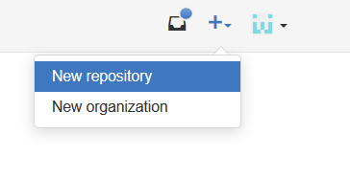

1. Choose appropriate repository name e.g. “SoftUni-QA-Course-Playground” and a description. Initialize the repository with a README.

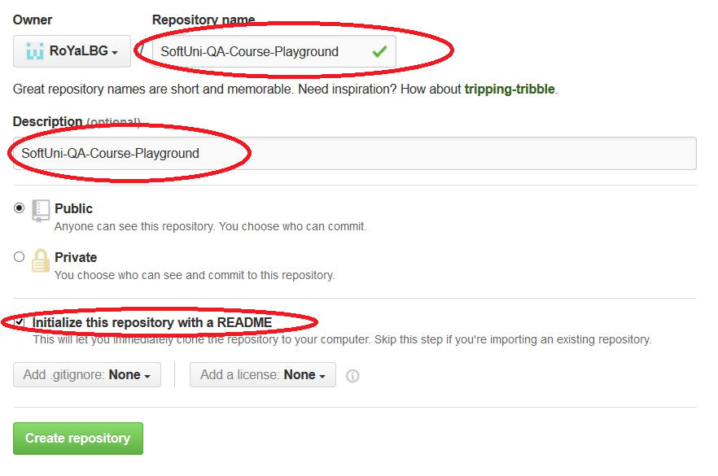

1. Click “Create repository”

## Play With GitHub Issues

### Task 1. Create new issue

After you are in your newly created repository follow the steps below

1. Go to Issues from the right sidemenu
2. Click “New Issue”
3. Write a simple issue, label it as a bug and assign it to yourself

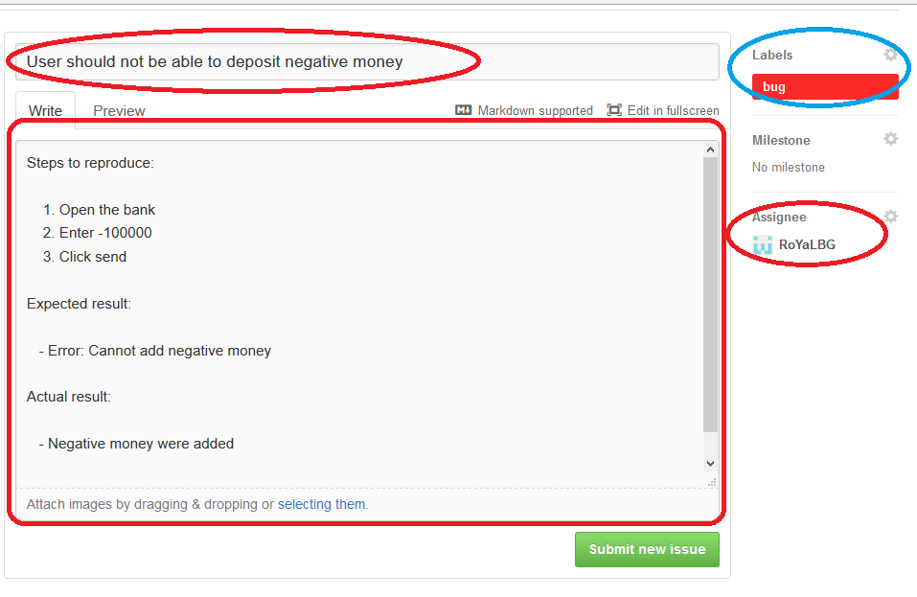

1. Click “Submit new issue”

### Task 2. Create issue linked to a problem

1. Commit a file to the repository
2. Create new issue labeled as a bug
3. Change something to the file and commit the changes. In the commit message refer to the issue id in the format “#issueId – some message here” e.g. “#5 – fixed negative money bug”
4. You can find the issue id when you open the issue and look at its title (the number after the # sign)

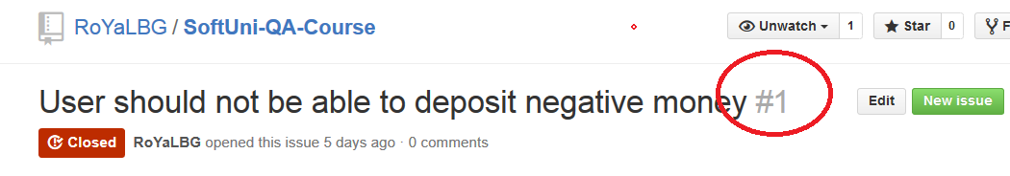

1. Check if it’s linked in the commits section

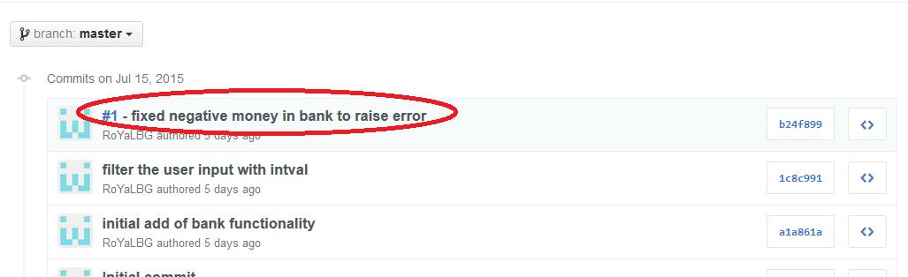

1. Check if It’s linked in the issue

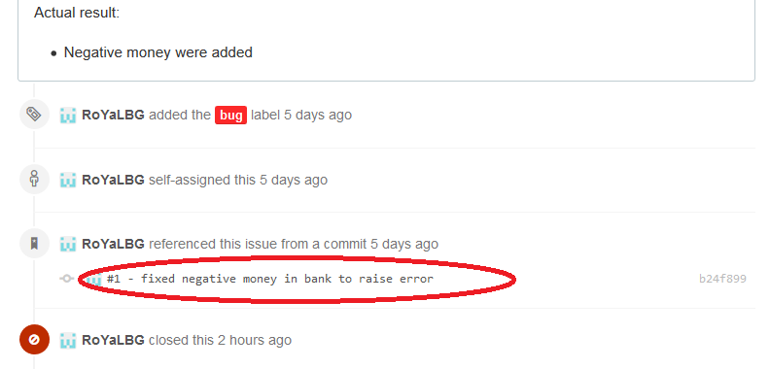

1. Close the issue